

（威海）

Report of Software Architecture

Homework 2.3-1: Singleton Pattern

Basic information
Team name： _______________________________

Class number: ____________________________________________________
Department/school：
Team members with student numbers：

_______________________

Instructor’s comments and score
comments：

score：
signature of the instructor：

Year month date
作业要求：See the following class diagram for the design of the internet connection problem in Singleton pattern in example 14.1.
JFrame
ClientGUI
- objLogon: LogonGUI
-issueWarning()
+actionPerformed(ActionEvent e)
JFrame
SingleLogonGUI
-instance: SingleLogonGUI;
+getInstance(): SingleLogonGUI
-isValideCustomer: boolean
-issueWarning()
-issueSuccess()
+actionPerformed(ActionEvent e)

Homework requirement:
- Run the ClientGUI program and you will see the following user interfaces.
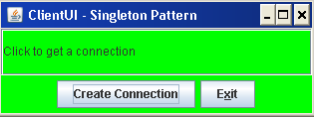
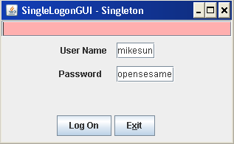

Be familiar with the source code.
- Use the thread safe Singleton pattern to redesign the above problem
- Write necessary code to implement your new design

Report Part

- What part of the old design has been changed in order to get your new design? Draw your new class diagram here.

- Answer questions
  - What are the differences between your new design and the old design?
  - In your new design, if a user clicks the button “Create connection” on the figure below twice, what will happen?

3. Answer questions:
- State the reason why the old design will keep the single thread client class ClientGUI from creating two different objects of the SingleLogonGUI.
- State the reason why your new design keeps the Client program ClientGUI (maybe multiple thread) from creating two different objects of the SingleLogonGUI?

4. (Testing part) Test your classes ClientGUI and SingleLogonGUI and put the testing input and output below.

